**Guide to Make Your Own Website From a HTML CSS Template**

This tutorial mainly consists of 3 parts

1. Download, install and account creation
2. Editing the template
3. Uploading the files on server
4. **DOWNLOAD, INSTALL AND ACCOUNT CREATION**

We need to download 2 software for our website

1. **Sublime Text Editor**

A text editor is needed for editing the files and Sublime seems to be the best one so far. It makes the boring looking code colourful and gives you references side by side.

1. **MAMP**

MAMP stands for ‘Mac Apache MySQL PHP’. It is used to test the files on our local browser before we upload it on the actual server. This is extremely helpful because uploading files again and again on the server is time consuming. MAMP gives instant editing results.

1. **Infinity free**

Infinity free is a website which gives you a free sub-domain based on their own domain. We can upload our files for free on that server. It is a good bet to test your website before spending money.

1. Download Sublime
2. Download Sublime for your OS here

<https://www.sublimetext.com/3>

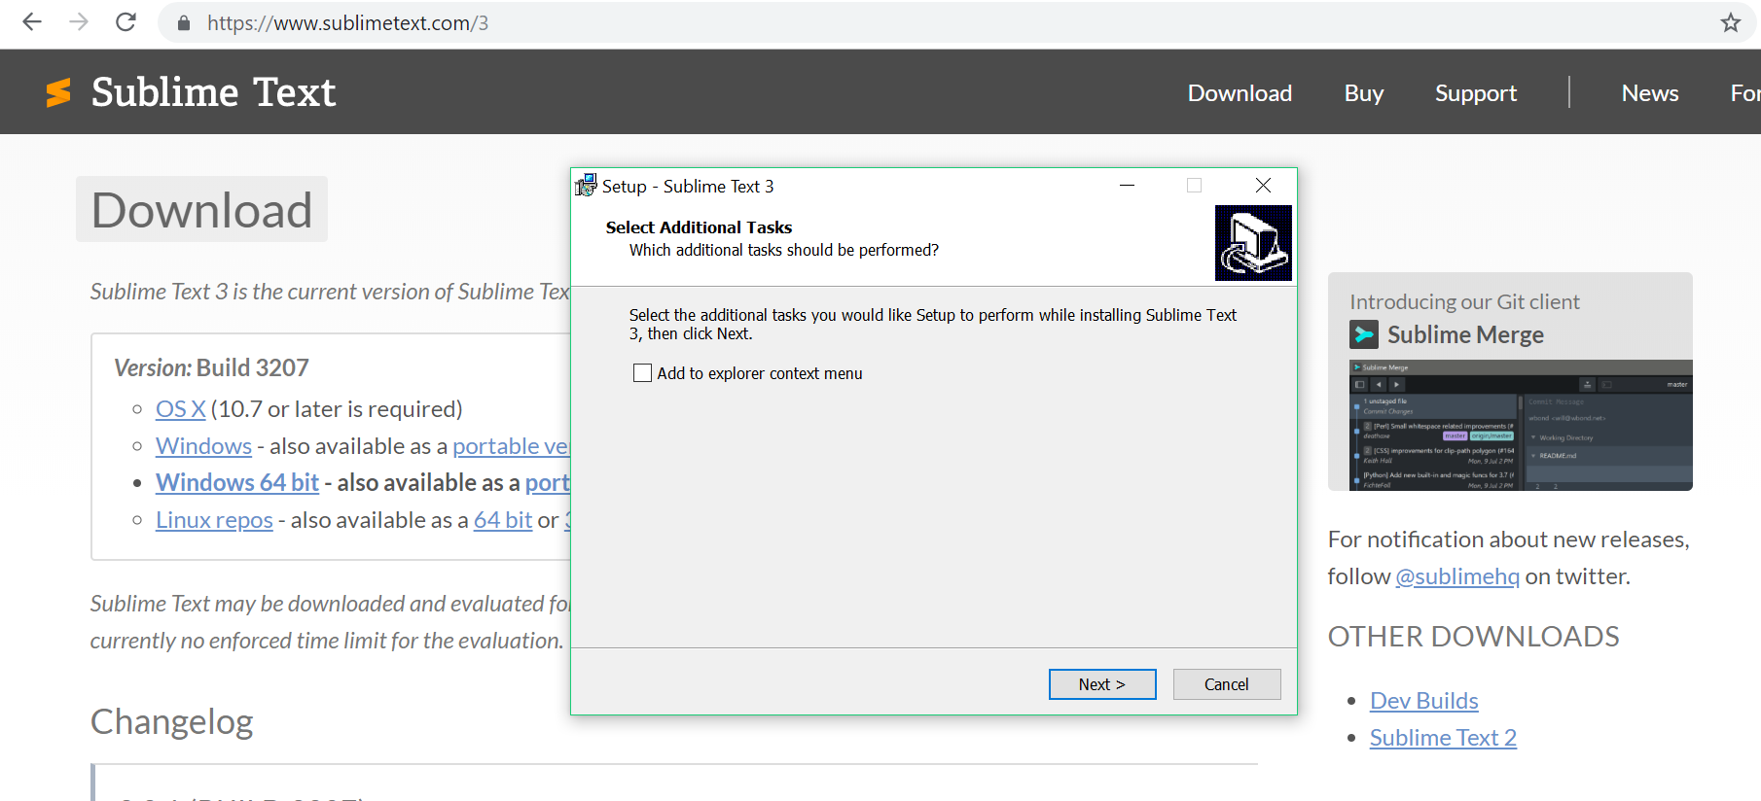

1. Install the editor
2. Search the text editor on this location (for Windows)

"C:\Program Files\Sublime Text 3\sublime_text.exe"

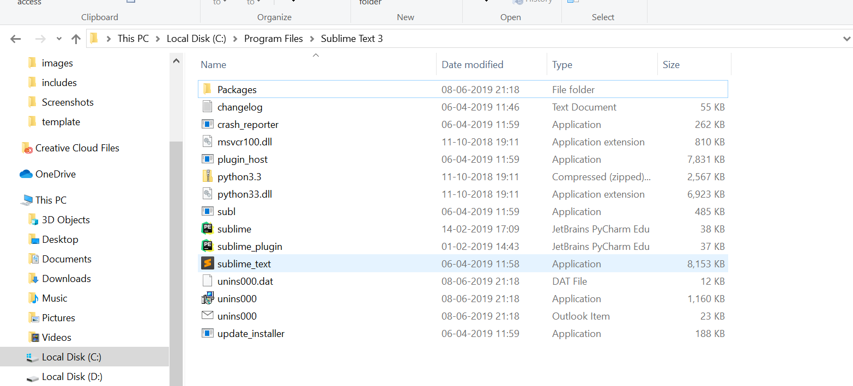

1. Create a shortcut on your desktop for easy access

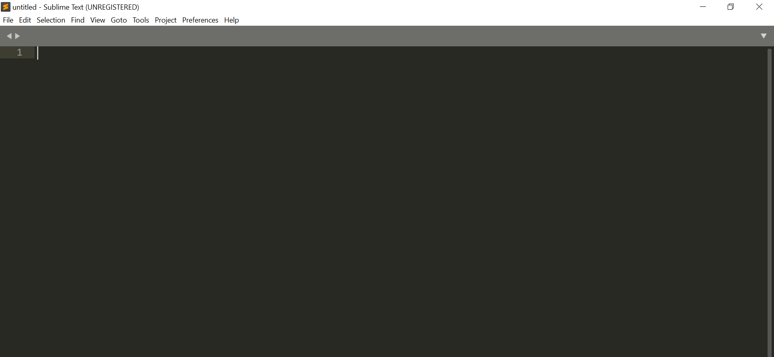

1. Download MAMP
2. Download MAMP for your OS from here

<https://www.mamp.info/en/downloads/>

1. Install MAMP
2. Search the text editor on this location (for Windows)

"C:\MAMP\MAMP.exe"

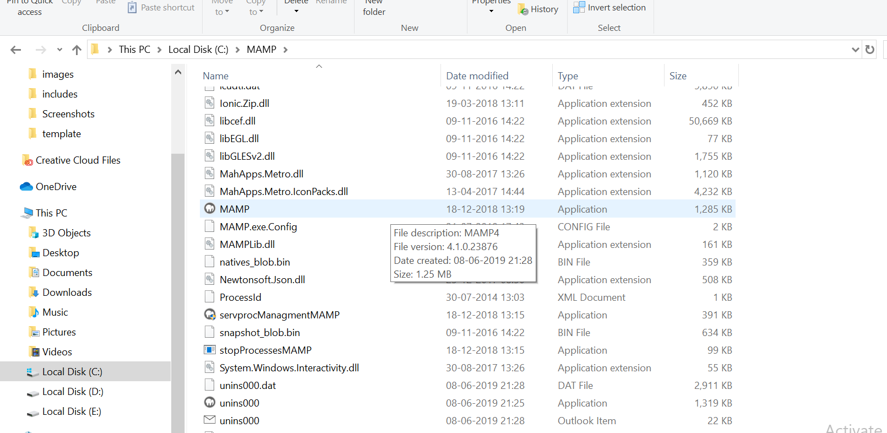

1. Create a shortcut on your desktop for easy access
2. Account Creation on InfinityFree
3. To create an account which is accessible publicly, please create your account here

<https://infinityfree.net/>

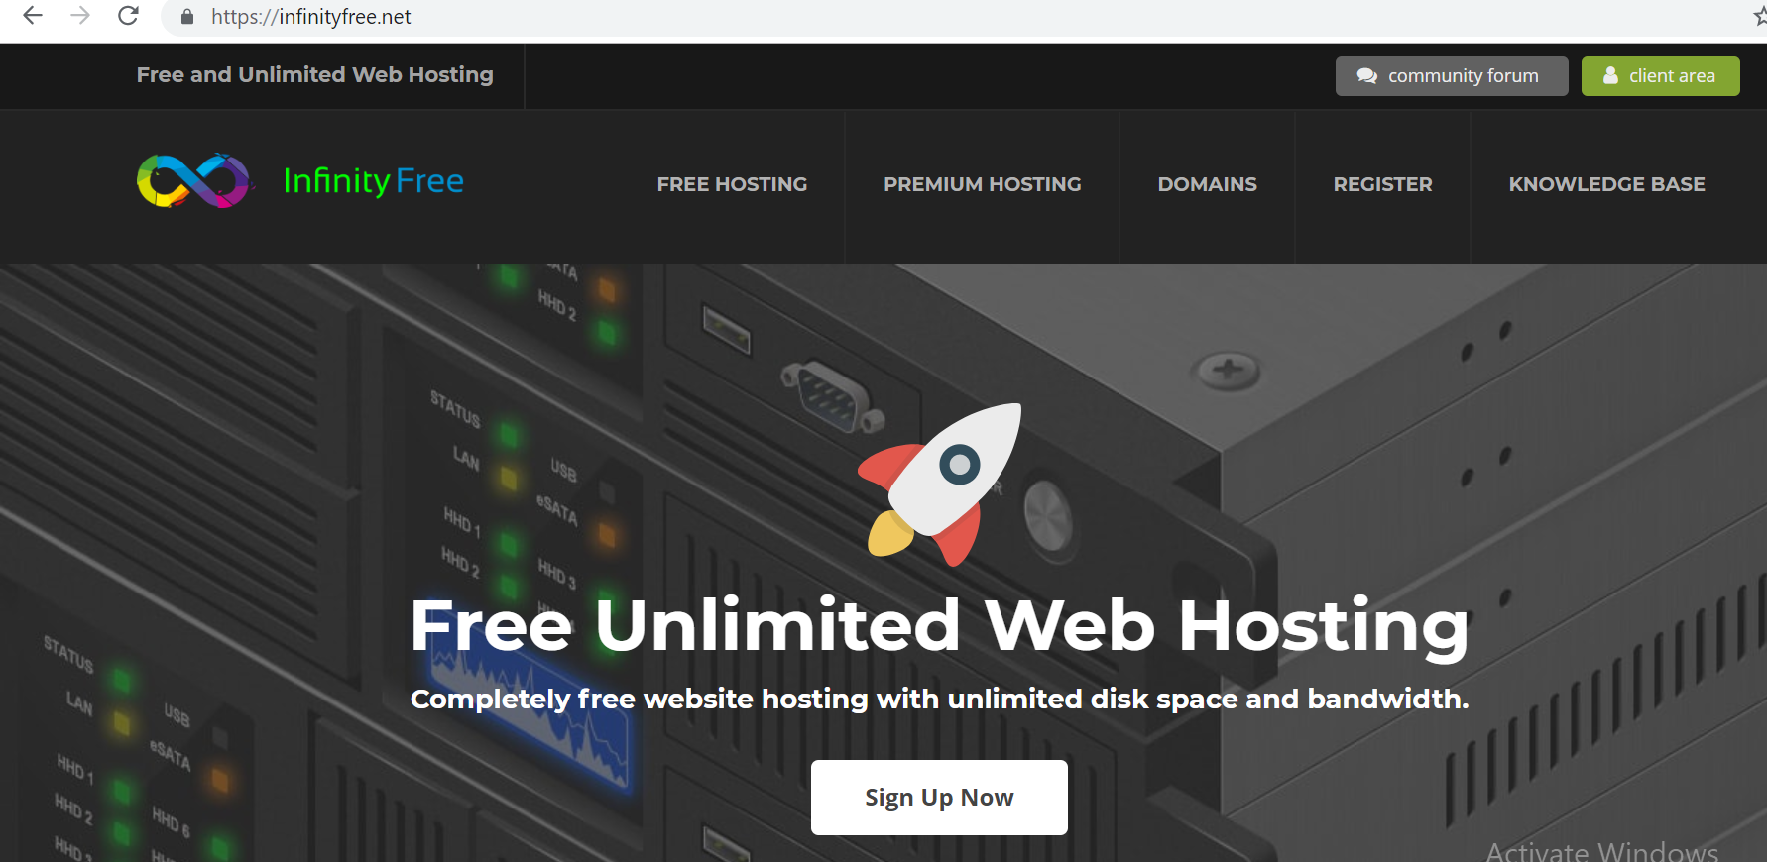

1. Go to Client Area
2. Click on Register Now

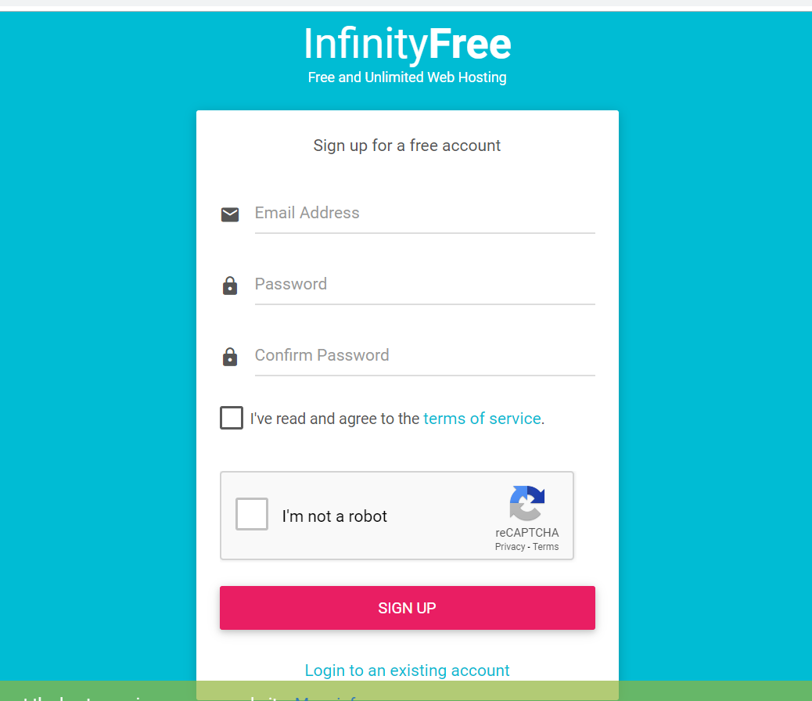

1. Fill up your details
2. A verification link will be sent to your account
3. Go to your email and verify your account
4. Click on ‘Create an account now’

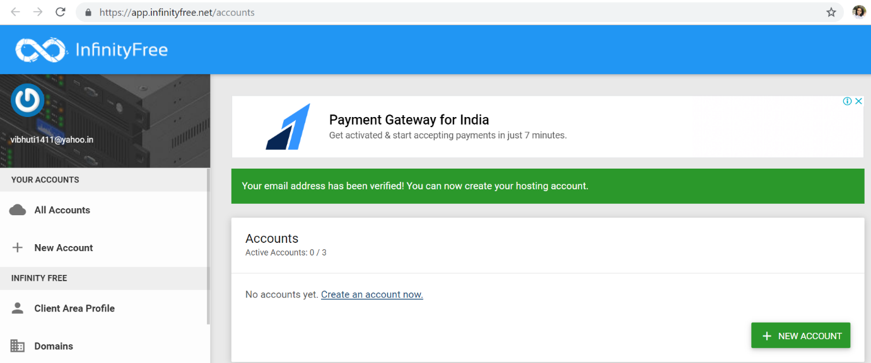

1. Enter your full name as your sub domain. Though you can choose any sub domain, choosing your own name will make it easier for everyone else to search for your portfolio later on. A subdomain can contain letters, numbers and dashes, but cannot start or end with a dash.

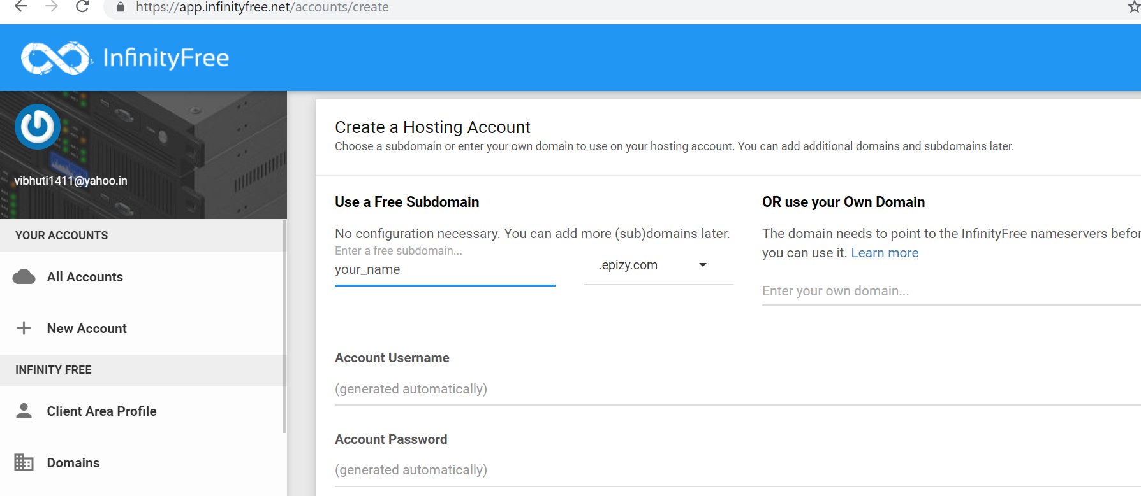

1. Keep the domain as ‘epizy.com’
2. Click on Create Your Account
3. Click on ‘View in Client Area’

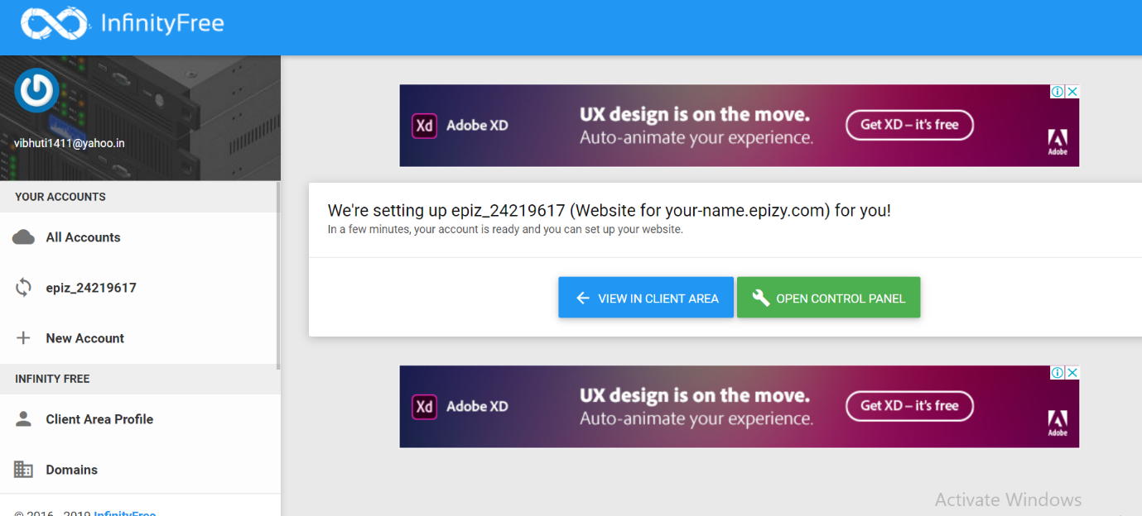

1. Please note the username and password for your account.
2. Click on Control Panel and hit Approve.
3. Account access on IIT Delhi web server

For detailed advice on setting up a user web page on IITD web server, please refer to this [link](http://www.cc.iitd.ac.in/CSC/index.php?option=com_content&view=article&id=107&Itemid=146).

For Bachelors and Masters students, user web pages are accessible with IITD WiFi only and the webpage is <http://privateweb.iitd.ac.in/~userid>

But the advantage of using IITD web server over epizy is in terms of file size. On epizy, you can upload a file with size limit of 10 MB of space but on IITD web server, there is no such restriction. On IITD server, you have a limit of upload of 5 GB data (need to doublecheck).

For PhD students and faculty, user web pages are accessible publicly and the webpage is <http://web.iitd.ac.in/~userid>

Windows users can download and install a popular ssh client called [Putty](http://www.chiark.greenend.org.uk/~sgtatham/putty/) and a popular GUI secure copy client called [WinScp](http://winscp.net/eng/index.php).

<https://winscp.net/eng/download.php>

Please enter your details as below:

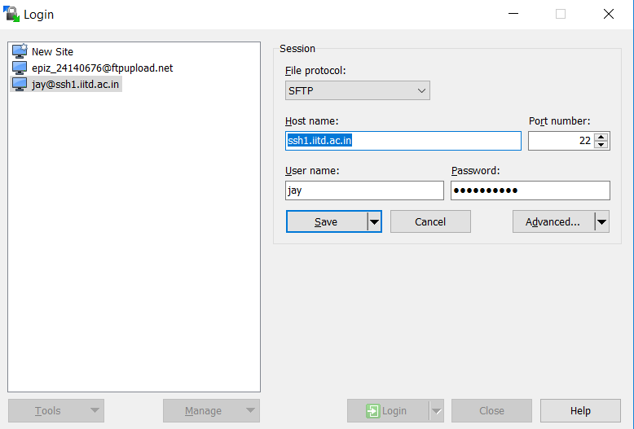

Hit save and click on Login.

The user should see the local files on the left side and the files and folders on the server on the right side.

Please upload files into the private_html folder (for Bachelors and Masters students) and public_html folder for others to have your webpage go live.

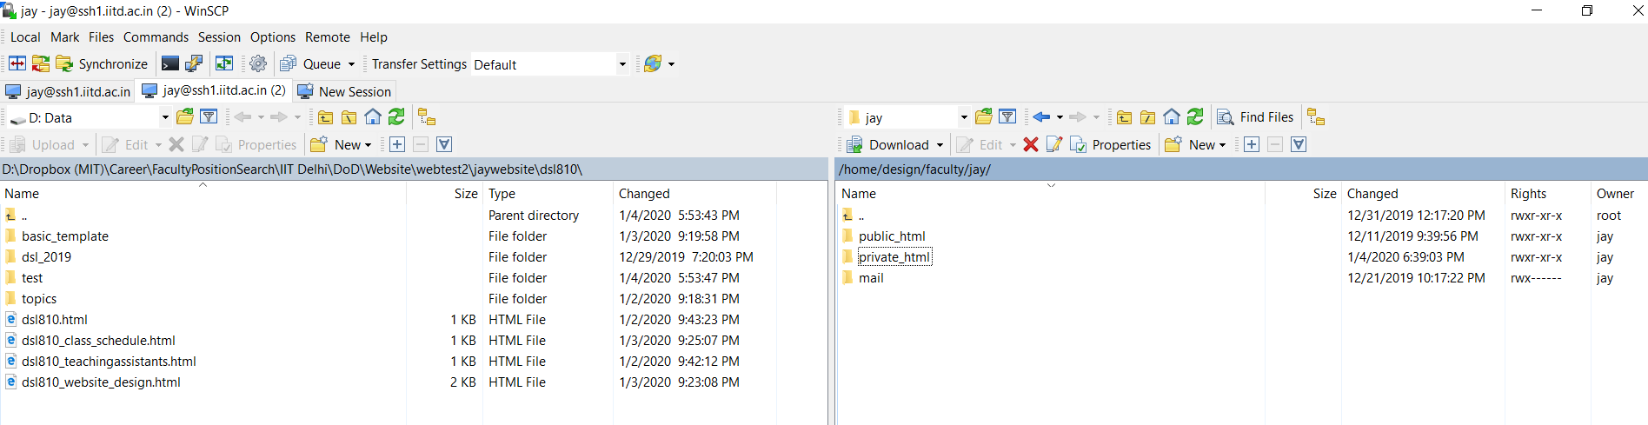

1. **EDITING THE TEMPLATE**
2. Downloading the files

Download the index2.html file and template folder and save them in MAMP🡪htdocs

Your folder should look something like this

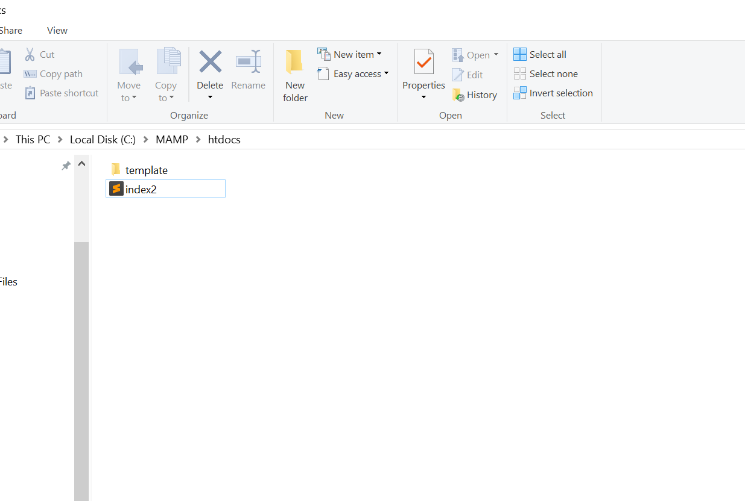

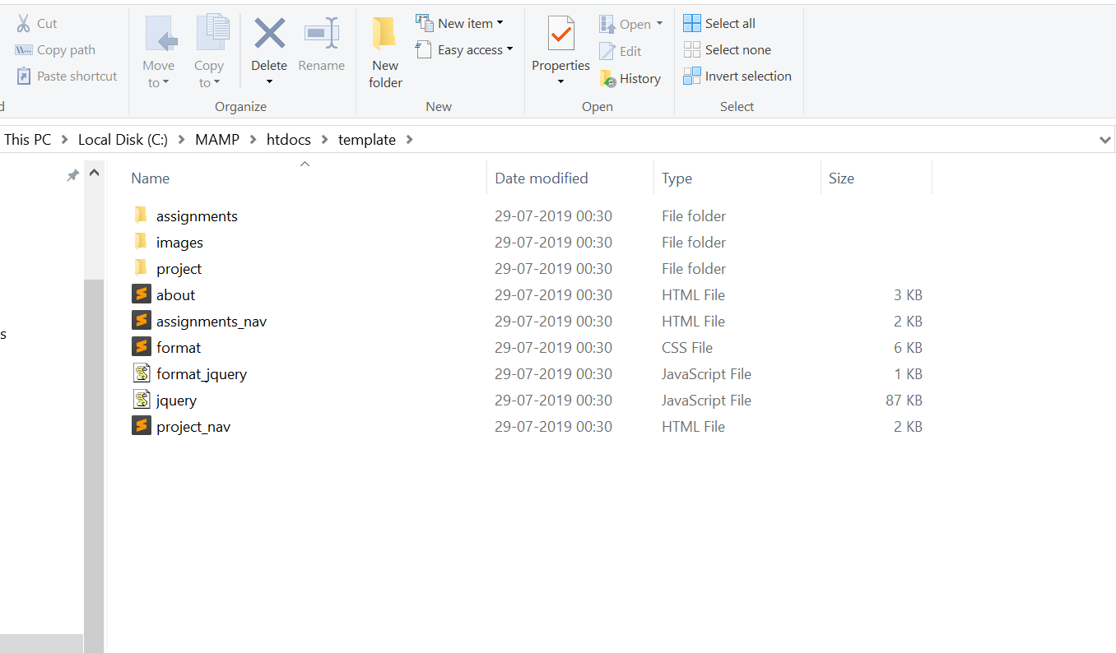

Now, before we dive in to edit the files, lets start with some common html tags. Tags are written in angular brackets.

1. Types of tags

There are two types of tags.

1. Tags with both starting and ending tags

example-paragraph, headings, lists, header, video, audio etc

1. Singular tags – break, image

**Some common tags**

1. **<p></p>**

**Paragraph tag**

Anything which is included within the paragraph tag will get a paragraph spacing and the text will be viewed as it is on the web.

Example-

<p>Let’s check out that portfolio!</P>

1. **<h1></h1>**

**Heading tags**

Any text enclosed within the heading tags will be bolded and size will be changed.

There are 6 types of heading tags based on their sizes

1. <h1>This will be the largest heading!</h1>
2. <h2>This will be somewhat smaller</h2>
3. <h3>This will be more smaller</h3>
4. <h4>This will be even more smaller</h4>
5. <h5>This is so small that it is rarely used</h5>
6. <h6>This is the smallest and is almost never used</h6>
7. **<br>**

**Break Tag**

* HTML is unaware of the spaces in the paragraphs or lines.
* It reads text continuously and can only show a single space between two words.
* To get more space, putting our words within tags is important.
* Either paragraph tag or break tag is used for it.
* Break tag will push the text after it, to the next line.
* If we use two break tags together, then we can see a line gap.

Example - <br><br>

1. **Listing**

There are two types of lists

Ordered lists – Lists which are numbered - **<ol></ol>**

Unordered lists – Lists which are bulleted - **<ul></ul>**

List items come in between these lists by the list tag

**<li></li>**

Example – Ordered list

<ol>

<li>Onion</li>

<li>Tomato</li>

<li>Apples</li>

</ol>

Unordered list

<ul>

<li>Onion</li>

<li>Tomato</li>

<li>Apples</li>

</ul>

1. **Anchor Tag**

**<a href=”complete_link”>**Text which opens the link**</a>**

* The href attribute has the link to go to a particular file
* Links can be used within the list tag also to connect our list items to separate pages.
* This will be frequently used.

1. **Image tag**

**<img src="images/picture_name.jpg" width="500px" alt="profile-picture">**

Use this tag to add images.

Mandatory attributes –

* src – It will include the location of the image with extension
* alt – It is a name we give to the image for the computer to read. Always add the alt attribute because if somehow your image fails to load, it will show this name
* We can also edit the width and height of the image.
* If you edit either width OR height, the aspect ratio of the image will be maintained.
* If you edit both, it will change.

1. **Video tag**

**<video width="200px" height="" controls autoplay>**

**<source src="videos/video_name.mp4" type="video/mp4">**

**</video>**

* Add videos in the videos folder and type their location in the src attribute. The videos should be in .mp4 format.
* Use the type attribute as it is.
* Control the width and height of the video using width and height attributes respectively.
* Add controls attribute to show the controls
* Add autoplay attribute only if you want the video to play automatically after the page has loaded.

1. **Audio tag**

**<audio controls>**

**<source src="/template/audio/audio_name.mp4" type="audio/mp3">**

**</audio>**

* It works similar to the video tag.
* Audio should be in .mp3 format

1. **Add videos from YouTube**

* Go to the video you want
* Click on share
* Click on embed
* Copy the iframe code and paste it in your file wherever you want the video to appear

1. **Comments**

**<!- - This is a comment-->**

* Comments are used to keep oneself updated of their own code.
* Basically comments are nowhere to be seen in the website.
* It is on the text editor for our convenience and to write notes.

I have added a lot of comments which will definitely help you to find your way through the page.

Since there are quite a lot of tags, but these are the basic ones which will help you edit out the code according to your needs.

1. Editing files

Now that the tags are out of the way, let’s start with finally editing our files!

1. **Index file**

* We’ll first start with the home page which is your index2.html file
* Open the index2.html file which should be directly in your htdocs folder
* Change your prefix from designer to anything else if you want, or delete it if you don’t want it
* Now type in your name in the required area.

You can also edit the home page images for both the desktop view and mobile view with their appropriate sizes. Add the images in the images folder and edit the srcset attribute. I recommend not to change the images at this point because it will only create confusion. Come back to this later if you really wish to customize the home page.

And that’s it! Your home page is ready.

Next up, we’ll edit the about section.

1. **About file**

* First of all, add your picture in the images folder which you would like to show on the website.
* Now open the about.html file
* Go to the img tag and edit the src attribute to locate your file. Add your picture name with the correct extension.
* Add content within the paragraph tag. Add as many paragraphs as you want.
* Bookmarking will be done for paragraphs which have sub headings.

Bookmarking is probably the trickiest part of editing but if you understand it once, then all other files have the same template.

**What is bookmarking?**

You can understand it as an index for a long document. You can scroll further down but your bookmark stays intact. It contains a shortcut which is linked to the sub headings. If you click on content from this ‘Table of Contents’ or bookmark or index, it will directly take you to that paragraph.

1. Give an id attribute to each sub heading in the h3 tag
2. The id should be unique for each sub heading
3. Now type the sub heading to be seen on the website
4. The id could be anything (but unique) from the name of the sub heading to just an iterating sub_heading_1, sub_heading_2 and so on. I have used the latter for simplicity.
5. Now go to the ‘Table of Contents’ above and add the name of the sub heading in the table.
6. The table of contents basically has all the contents in the form of a list.
7. Add the id in the ‘a’ tag in the list using the href attribute. Simply copy paste the id of the sub heading here.
8. Include a # symbol immediately before the id within the double quotes.
9. Type your sub heading in the table of contents.
10. Now when you click on the sub heading in the table of contents, it will take you directly to that part of the paragraph with that sub heading.

Still unclear how bookmarking works? Watch this

<https://www.youtube.com/watch?v=Sh6kXmNkkEM&list=PL41lfR-6DnOq3BebucTNMSVDojCIiv_en&index=8&t=0s>

1. **Assignment**

* Go to the assignments folder and open the assignment_template.html file.
* Add your content by adding headings, paragraphs, images, videos etc.
* Bookmark your content in a similar fashion with the ‘Table of Contents’.
* IMPORTANT – Save your file as a new file otherwise you’ll lose the template to create other assignments.
* IMPORTANT – Save your files with html extension

1. **Assignments Navigation**

* This is a list of all the assignments.
* Add your assignment name in the list using the ‘a’ tag.
* Add the name of the file.

1. **Project Proposal and Final Project**

These files have the same template as the assignments file and therefore work similarly.

So, we are done with a basic tutorial! I know reading and theoretically might seem daunting. And to clear your doubts, you can watch some of the videos of this tutorial.

<https://www.youtube.com/playlist?list=PL41lfR-6DnOq3BebucTNMSVDojCIiv_en>

I’d recommend up to 11 videos. It wouldn’t take much time. This is where I learnt HTML from and it’s really easy.

1. **Uploading Files on Server**
2. Testing Files on Local Server

* Open MAMP

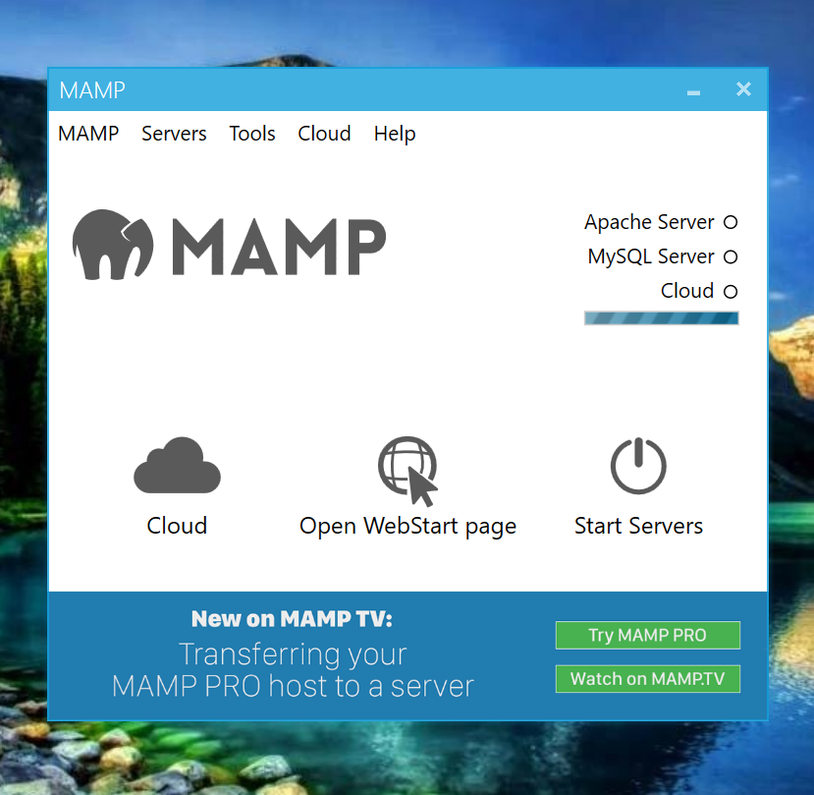

* Click on Apache server and then click on Start Server
* Wait for a few seconds after clicking on both.
* You should see this after clicking on those two buttons

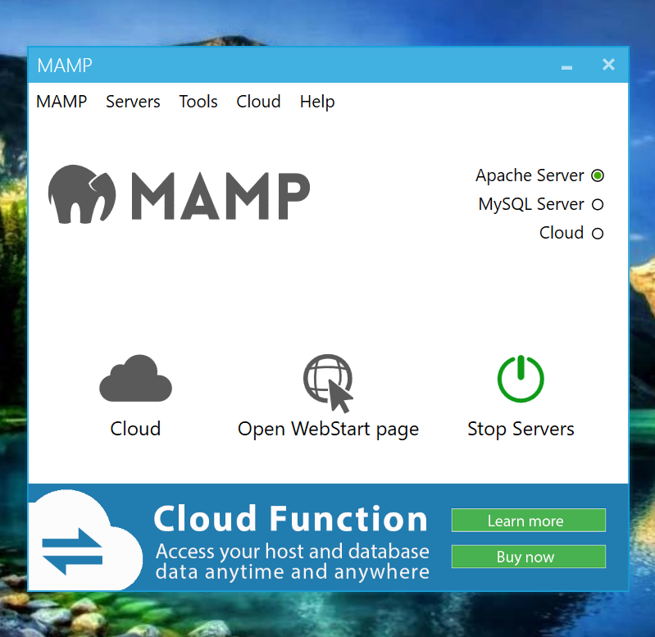

* Now open your browser and type – localhost/index2.html
* You should see your edited files.
* Make changes however you want, refresh the browser and check.
* Once you are satisfied with the files, it’s time to upload them to the server for everyone to see.

1. Uploading Files on Infinity Free

By now, your website would be up and running

* Go to the file manager

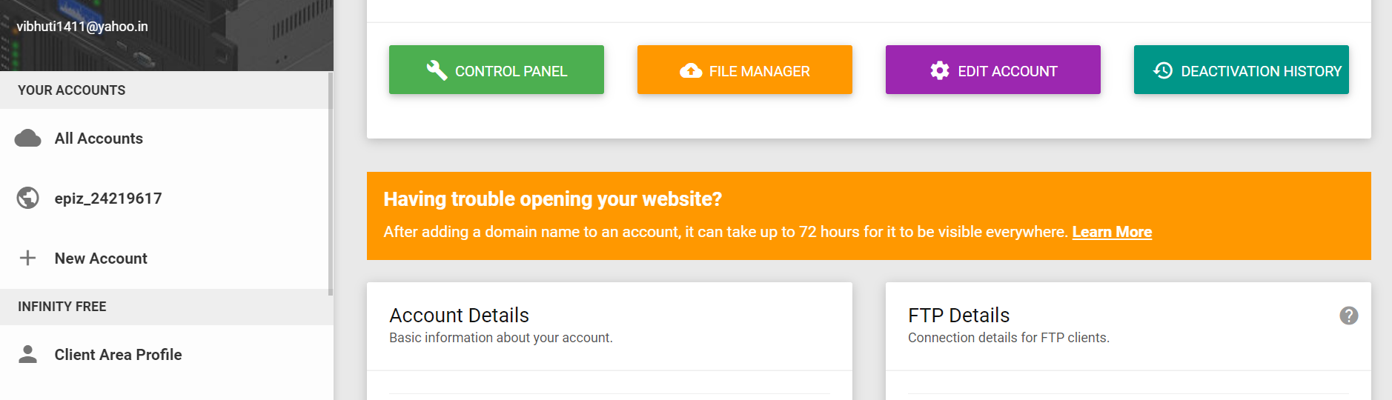

* A new window will be opened
* Click on htdocs

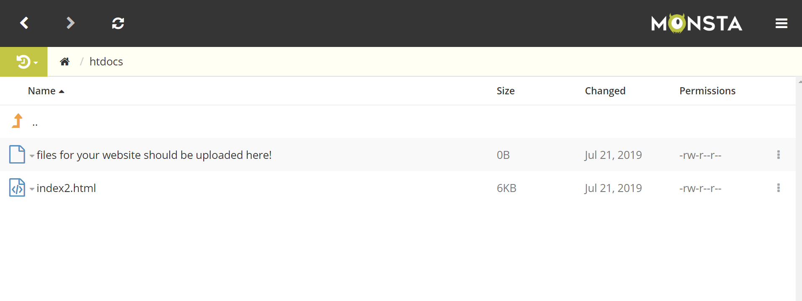

* Delete the 2 already existing files

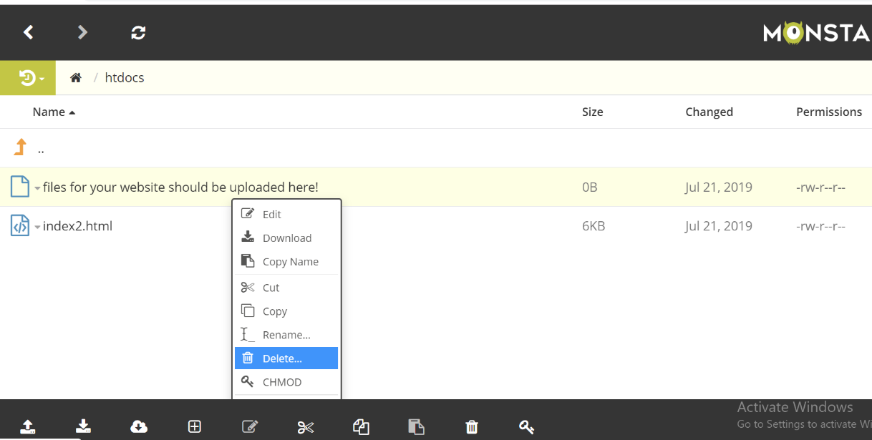

* Upload your index2.html file and template folder
* It should look something like this

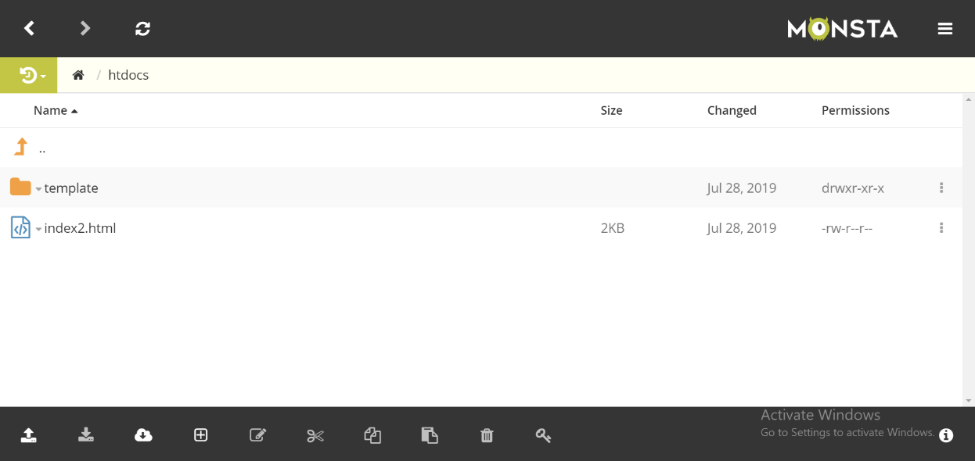

* Your template folder will have all other files
* NOTE – Now whenever you wish to upload a new assignment, simply go to the assignments folder and upload the new file. Also don’t forget to first delete the current assignment_nav.html and upload the new assignment_nav.html with the added list item of the new assignment. Similarly, replace the old project files with the new ones.

Now search for your website in the browser. Your website will be up and running!

* NOTE – If you can still see your old files after updating or something really weird like a mix of old and new files, just delete your cache history and refresh and it will work fine.
* NOTE - Press Ctrl+F5 for hard refresh.

1. Uploading Files on IIT Delhi web server

The user should see the local files on the left side and the files and folders on the server on the right side.

Please upload files into the private_html folder (for Bachelors and Masters students) and public_html folder for others to have your webpage go live.

